Project Development Phase
Model Performance Test

Date | 27 July 2025
Team ID | PNT2025TMID08395
Project Name | Visualizing Housing Market Trends: An Analysis of Sale Prices and Features using Tableau
Maximum Marks

Model Performance Testing:
Project team shall fill the following information in model performance testing template.
S.No. | Parameter | Values | Screenshot
 | Model Summary | - | 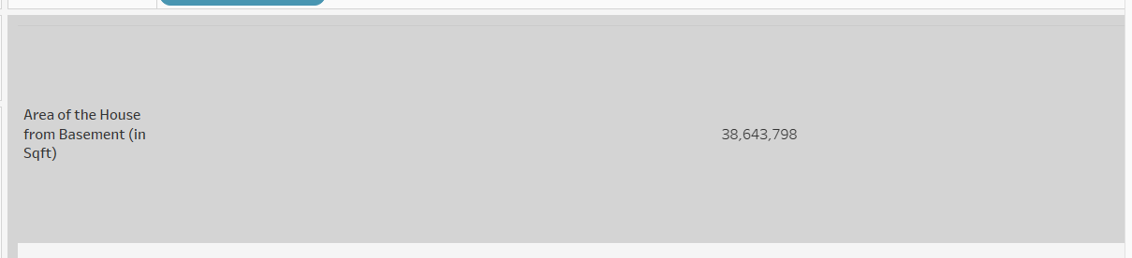
 | Accuracy | Training Accuracy – 80 %  Validation Accuracy – 75% | 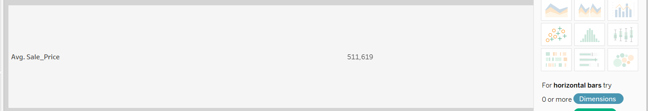
3. | Fine Tunning Result( if Done) | Validation Accuracy – 75% | 